Lab 3 Report: Uninformed Search Algorithms
Course: Artificial Intelligence Lab
Topic: BFS, DFS, DLS, IDDFS & UCS Algorithms
1. Trigger Questions (Courage - Thinking)
Q1: Why can DFS reach a deep dead end quickly?
Answer:
DFS uses LIFO (stack behavior) and explores as deep as possible along each branch before backtracking. If a deep branch contains no goal node, DFS will explore all its descendant nodes to the end before attempting alternate shallower branches.
Q2: Why does BFS require substantial memory?
Answer:
BFS stores all generated nodes at the current depth level in the frontier (queue) before moving to the next depth. For a graph with branching factor b and goal depth d, memory complexity is O(b^d), which grows exponentially with depth.
Q3: How does a depth limit change DFS behavior?
Answer:
A depth limit forces DFS to halt exploration beyond a specified depth limit L. This prevents DFS from falling into infinite paths or deep dead ends, making it time-bounded (O(b^L)).
Q4: Why can UCS return a different route from BFS?
Answer:
BFS measures distance by the total number of hops (edges), choosing the path with fewest steps. UCS expands nodes based on total accumulated path cost (g(n)). Thus, UCS chooses a path with more hops if its total step cost is cheaper than a shorter path with higher edge weights.
2. State-Space Formulation
Initial State: Node A (Starting point).
Actions / Successor Function: Transitioning to adjacent connected nodes based on graph adjacency list.
Goal Test: Is Node == 'G' (Exit location).
Path Cost: Sum of edge weights along the traversal path (1 unit per edge for unweighted; specified costs for weighted graph).
- Algorithm Complexity Comparison
Strategy: BFS
Complete?: Yes (if branching factor b is finite)
Optimal?: Yes (for equal step costs)
Key Resource Behaviour: High memory demand at broad depths O(b^d)
Strategy: DFS
Complete?: Not always (can get trapped in loops)
Optimal?: No
Key Resource Behaviour: Low memory O(b * m), can go deeply into dead ends
Strategy: DLS
Complete?: If limit L >= d
Optimal?: No
Key Resource Behaviour: Depth bounded O(b * L)
Strategy: IDDFS
Complete?: Yes
Optimal?: Yes (for equal step costs)
Key Resource Behaviour: Repeats shallow work, optimal space efficiency O(b * d)
Strategy: UCS
Complete?: Yes (with positive step costs)
Optimal?: Yes
Key Resource Behaviour: Uses priority queue sorted by total accumulated cost
- Emergency Exit Graph Experimrnt & Output Trace
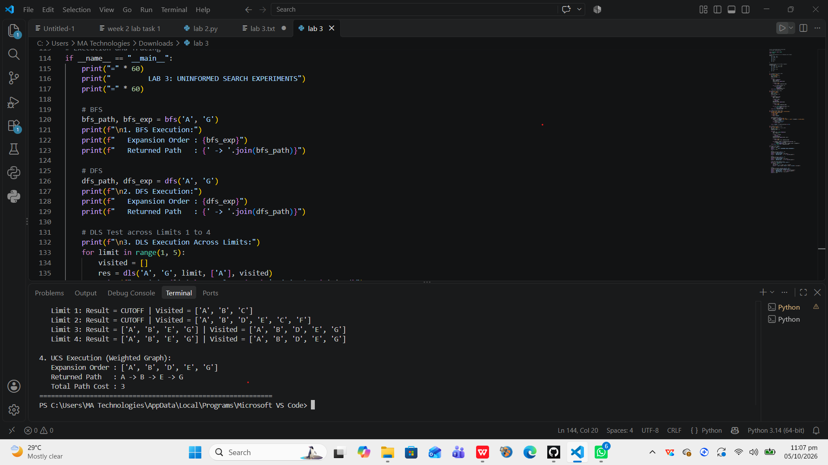
5. Reflection Questions
Q1: What did you learn today?
Answer:
I learned how uninformed search algorithms traverse state spaces, how stack vs. queue structures change search behavior, and why UCS is necessary when edge costs vary.
Q2: How will you apply this in a real AI system?
Answer:
I will apply UCS and BFS for pathfinding and navigation in robotics and emergency routing where path optimization is required without explicit heuristic estimations.
Q3: What failed or surprised you?
Answer:
I was surprised to see that BFS selects a path with fewer edges even if it has a much higher path cost, whereas UCS handles path costs correctly despite taking more hops.
Q4: What would you do differently next time?
Answer:
Next time, I would implement informed search strategies like A* Search by adding heuristic functions to improve search efficiency.

